**CHAMELI DEVI GROUP OF INSTITUTIONS**

**INDORE (M.P.)**



Rental Zone

**Mini Project Report**

**CS604- Project Management**

**Submitted By:**

Hatim Saifee Press Wala 0832CS191074

Karun Mourya 0832CS191088

Khushhal Gupta 0832CS191089

Murtaza Barwahwala 0832CS191110

**Guided By:**

Ms. Madhu Sharma

Asst. Professor, CSE Dept.

CDGI Indore

**DEPARTMENT OF COMPUTER SCIENCE & ENGINEERING**

**CHAMELI DEVI GROUP OF INSTITUTIONS**

**INDORE (M.P.)**



**DEPARTMENT OF COMPUTER SCIENCE & ENGINEERING**

**CERTIFICATE**

This is to certify that Mr. Hatim Saifee Press wala , Mr. Karun Mourya , Mr. Khushhal Gupta, Mr. Murtaza Barwahwala with RGTU Enrollment No. 0832CS191074, 0832CS191088, 0832CS191089, 0832CS191110 have satisfactorily completed the Mini Project on Rental Zonein **“CS604-Project Management”**, for **B. Tech, VI Semester** of the **Computer Science & Engineering** during year **2021 – 22**.

**Prof. Shailendra Kumar Mishra Signature of**

**Head of the Department Faculty In-charge**

__________________________

**TABLE OF CONTENTS**

|  |  |
| --- | --- |
| **CONTENTS** | **PAGE NO.** |
| Introduction of the Project | 1 |
| Description of the Project | 2 |
| Technical Details of the Project | 3-4 |
| System Design | 5-8 |
| Screenshot of the Code (Min. 3) | 8-10 |
| Screenshot of working Project (Min. 5) | 10-12 |
| References | 13 |

**Introduction of the Project**

RENTISH is a website that will provide rental service for real estate property, vehicles, household appliances, furniture, electrical products etc.

On this website people who want to rent or want to explore the possibility of renting will visit. When they come they will land on the home page. where they will get to explore all the items they can rent. There will be an option to search where the user will get to search items according to their need. There will be a login or register page where new users will register themselves. Users will have to register themselves by filling in all their detail. From the home page, users can go to different sections of the fields which they want to explore. Their user can see all the details about the product with images. When the user finds the product they will be able to click on the rent button. From there they will be redirected to the rent page of that product which will show all product details with product ID and payment summary. On that page, users will have to mention the duration for which they want to rent the item. According to which their payable amount will be shown with deposit.

From there users can go back to exploring more suitable items or can click on confirm button. which will take them to a payment page where they will be able to select the payment method they prefer. After payment confirmation, they will land on confirm page.

After renting the item and using it the person will be able to go to the order menu and will be able to return it by clicking on the return button. If the rent duration ends and the user does not return the item he will be charged per day for it.

Users will be able to give feedback on the order by going on the feedback option on the item they have already rented. They will find the feedback option when he opens the product he already rented in my orders.

**Description of the Project**

Renting items have become an important factor in modern society hence the need to have a website for it. In India, everyone tries to find a way to save money By taking the best he can at least cost. Every Indian goes for the most efficient choice. And renting is most efficient for short period.

Study of already available open-source websites developed in metro cities and foreign countries. There are many other renting websites which give cars, bikes and other gives furniture and few gives appliances. we will study all these websites and give an advance combination in rentish. So we will Analyse the foreign website and modify it according to our local needs.

We will try to develop an efficient website that will be helpful to users and will bring out the best in the technical renting world.

In our project, we will be using Agile methodology. In agile methodology, we do development and testing simultaneously. Agile methodologies attempt to produce the proper product through small cross-functional self-organizing teams that produce small pieces of functionality regularly, allowing for frequent customer input and course correction as needed.

**Technical Details of the Project**

Hardware Interface:

Development End

Hardware Specifications (Recommended):

Processor : i3 Processor

Storage : 10 GB

RAM : 4 GB

Software Specifications (Recommended):

Operating System : Windows 10

Browser : Chrome Brower Version 96.0

Designing Tool : VS Code

Front End : React Version 17.0.2

Back End : Express.js Version 4.17.1, Node.js Version 16.13.0

Database : MongoDB Version 4.4

Deployment End

Server Side

Hardware Specifications(Recommended):

Processor : Quad Core Processor

Storage : 50 GB

RAM : 4 GB

Software Specifications(Recommended):

Operating System : Windows 10

Browser : Chrome Version 96.0

DBMS : MongoDB Version 4.4

Client Side

Hardware Specifications(Recommended):

Processor : Dual Core Processor

Storage : 10 GB

RAM : 512 MB

Software Specifications(Recommended):

Operating System : Windows 10

Browser : Chrome Browser 96.0

**System Design**

1 Use Case Diagram

a) Admin

Fig 1.1 : Use case (Admin)

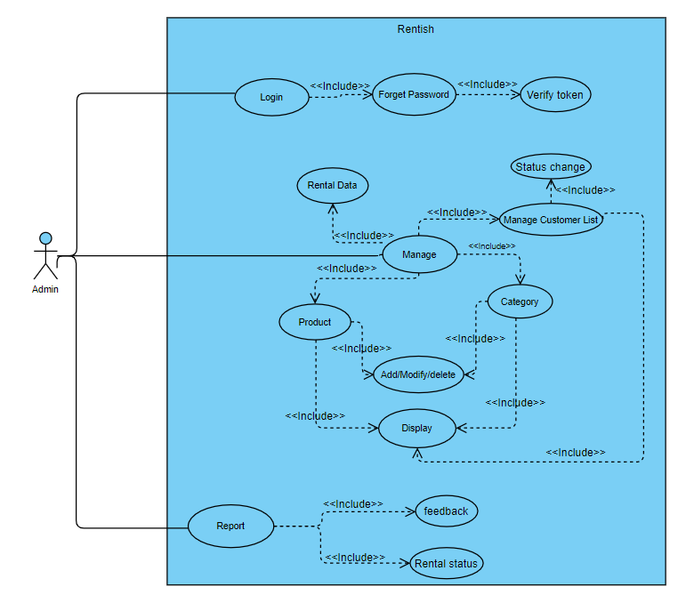

b) Customer

Fig 1.2 : Use case (Customer)

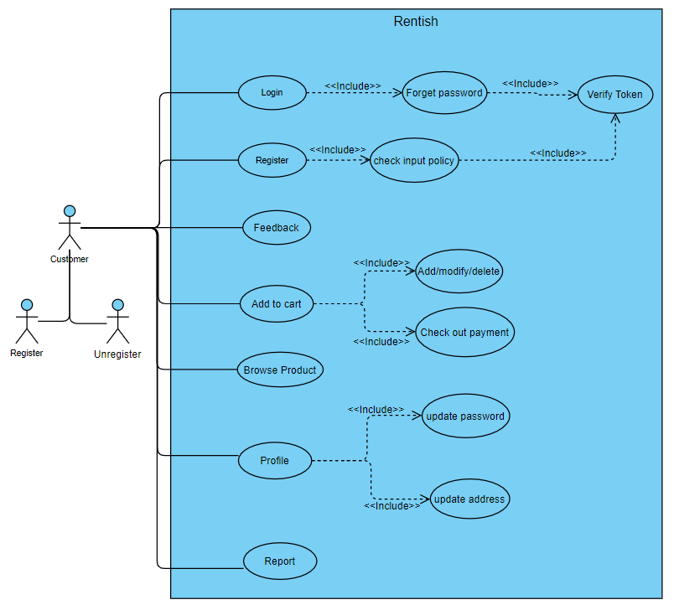

2 Activity Diagram

a) Admin

Fig 2.1 : Activity (Admin)

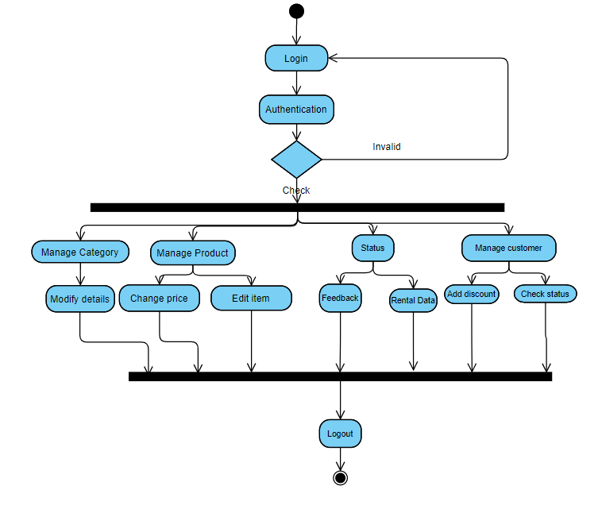

b) Customer

Fig 2.2 : Activity (Customer)

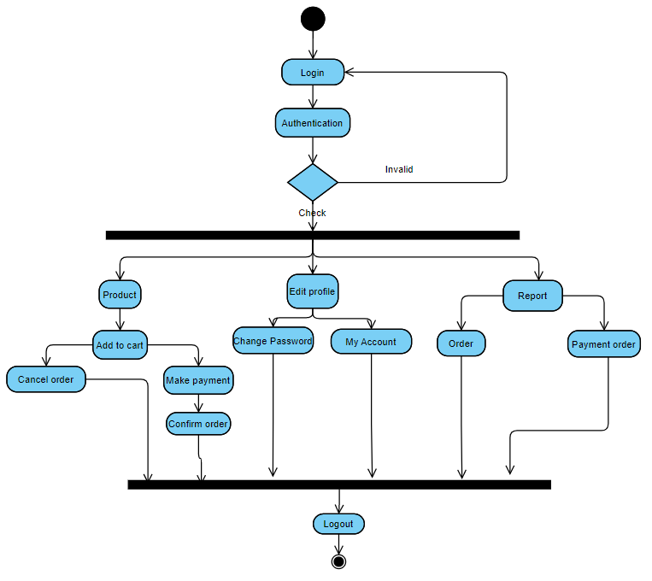

3 Sequence Diagram

a) Admin

Fig 3.1 : Sequence Diagram (Admin)

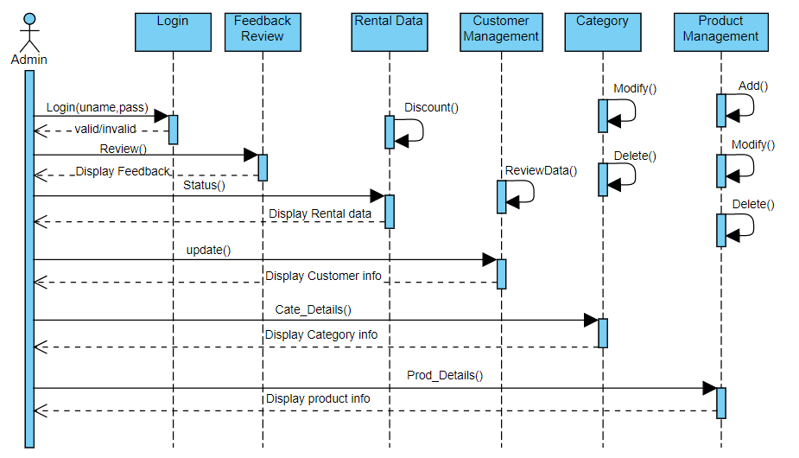

b) Customer

Fig 3.2 : Sequence Diagram (Customer)

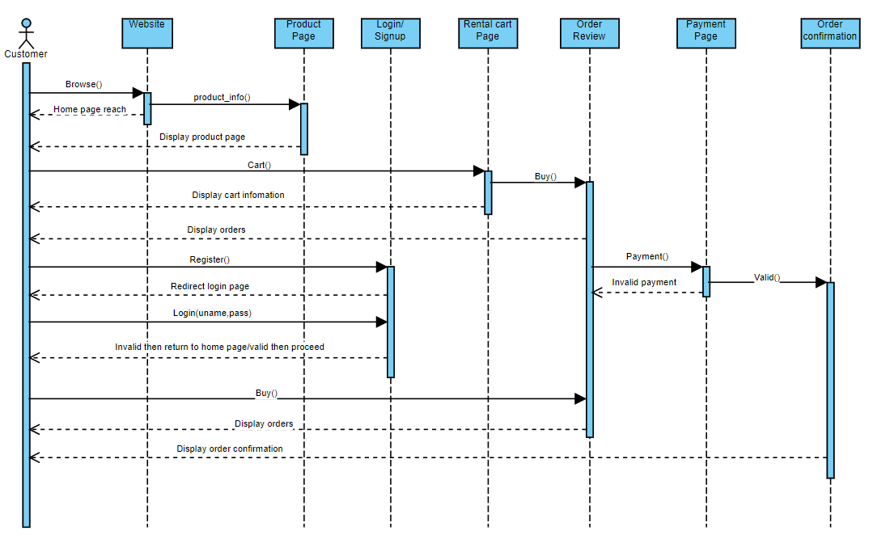

4 ER Diagram

Fig 4.1 : ER Diagram

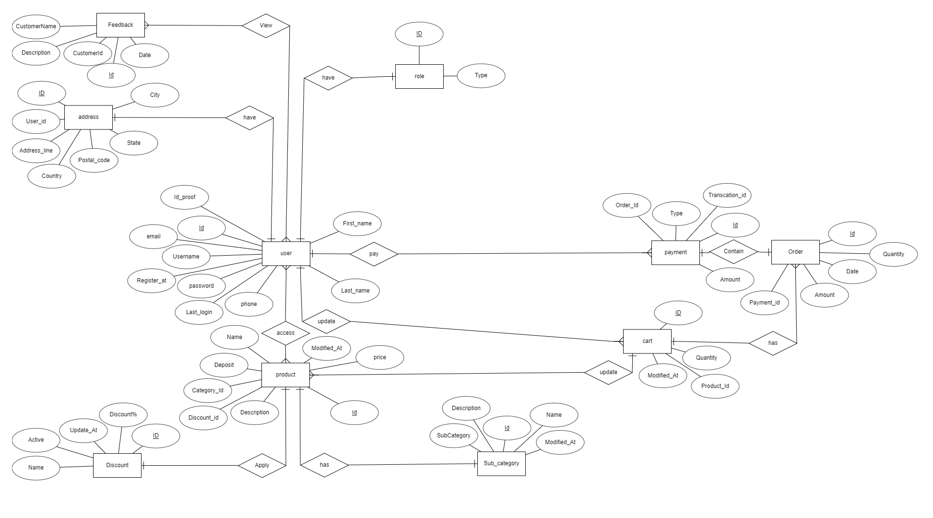

5 System Architecture

Fig 5.1 : System Architecture Diagram

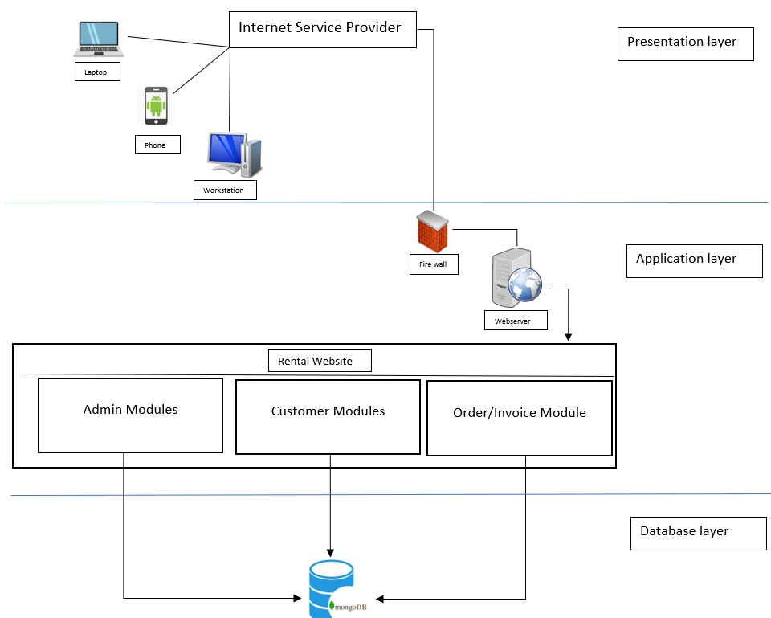

**Screenshot of the Code**

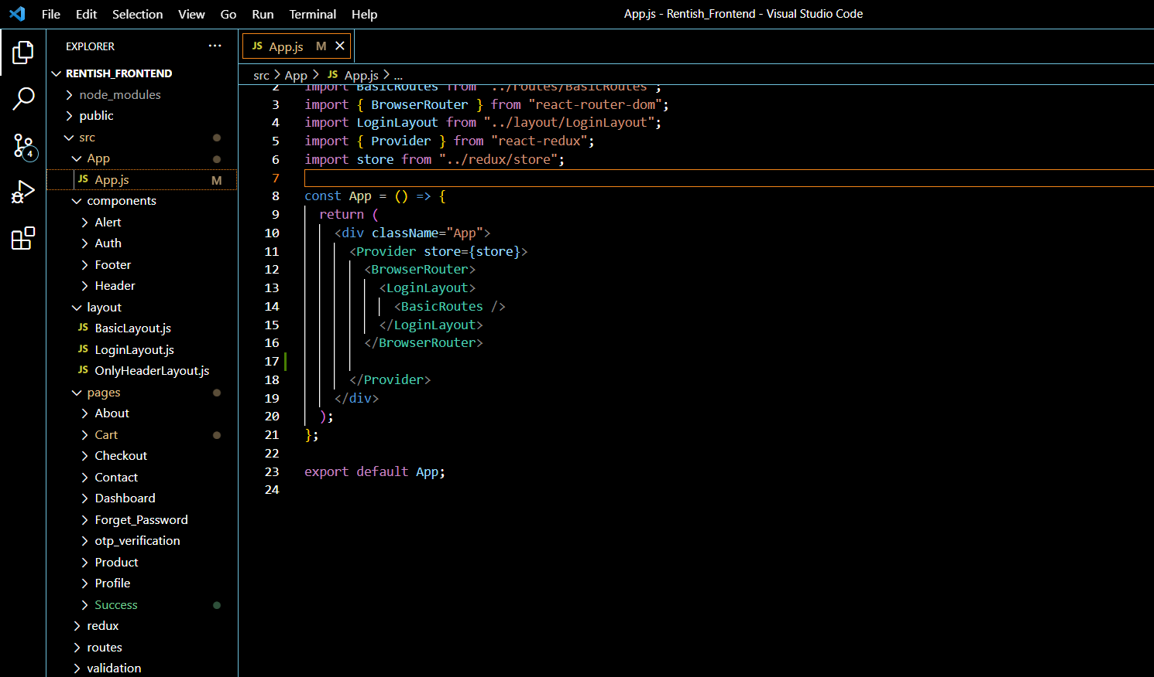

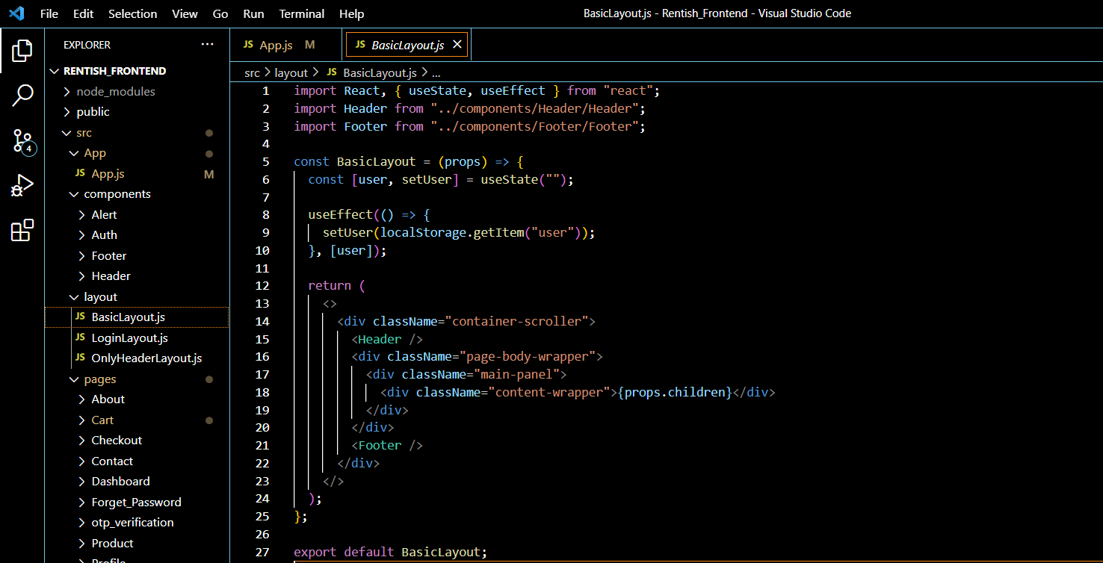Fig 6.1 Code 1

Fig 6.2 Code 2

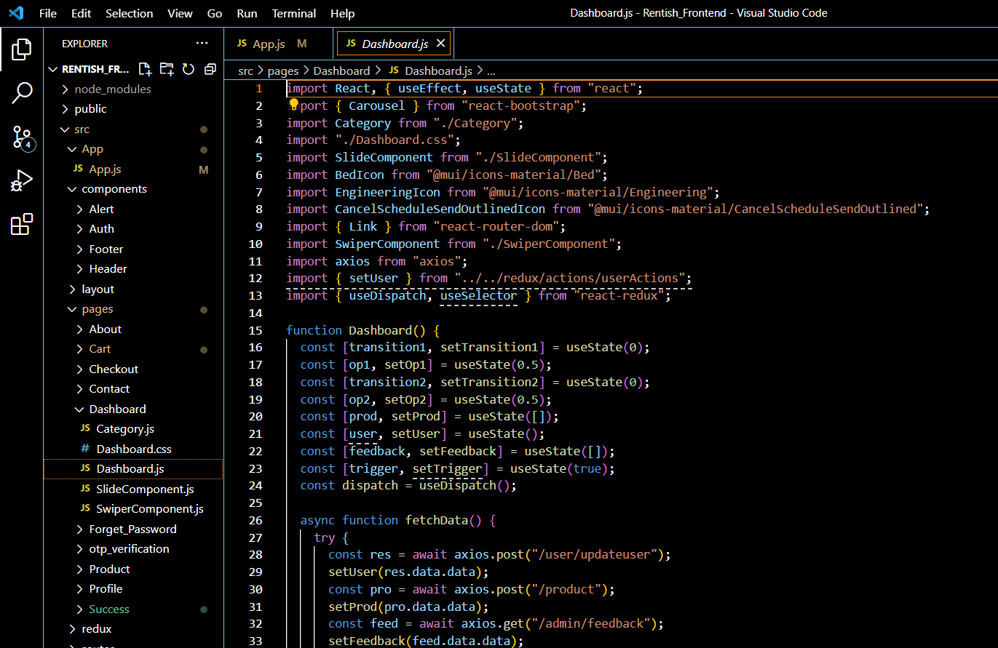

Fig 6.3 Code 3

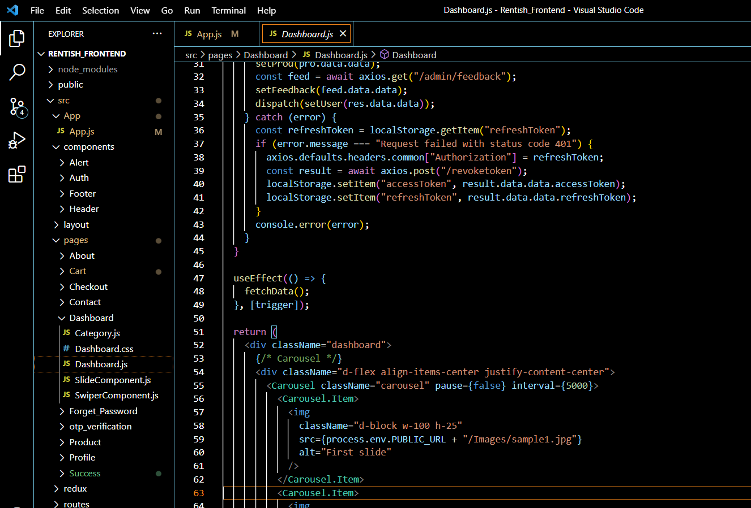

Fig 6.4 Code 4

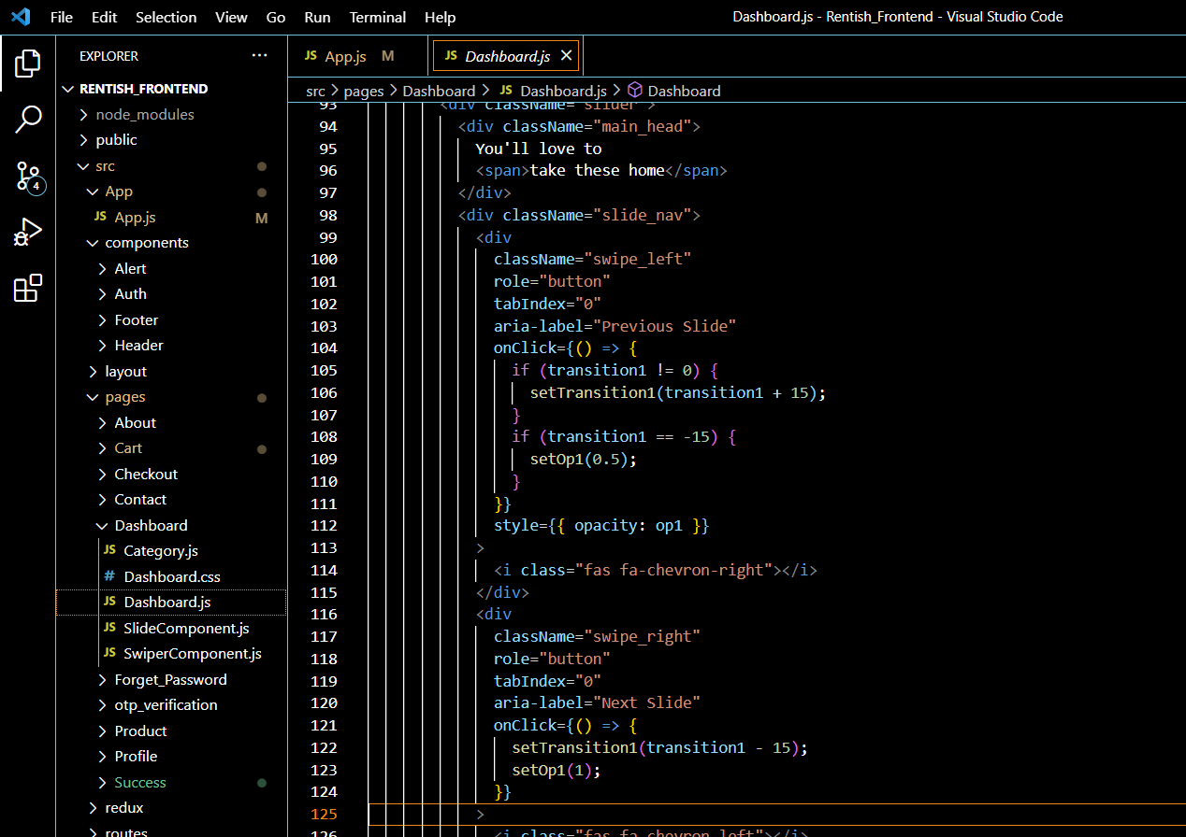

Fig 6.5 Code 5

**Screenshot of working Project**

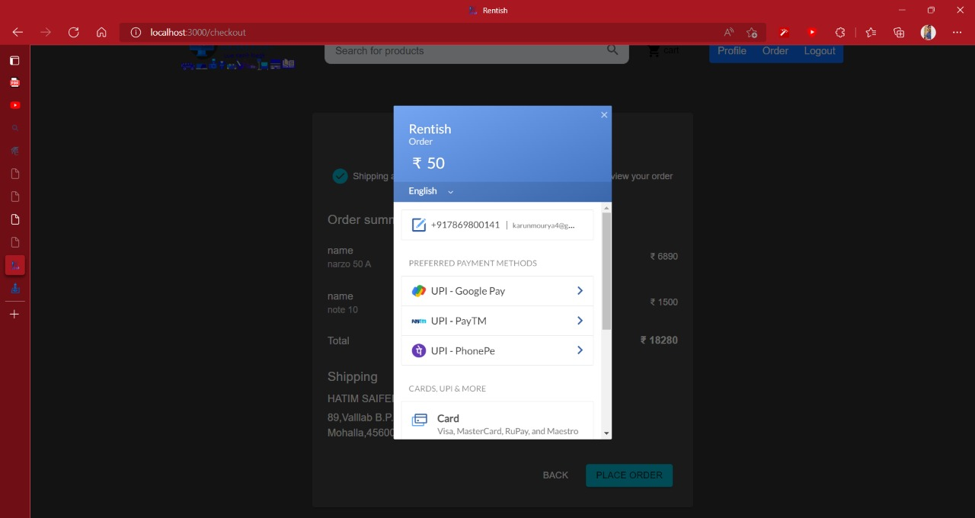

Fig : .7.1 Razorpay payment gateway

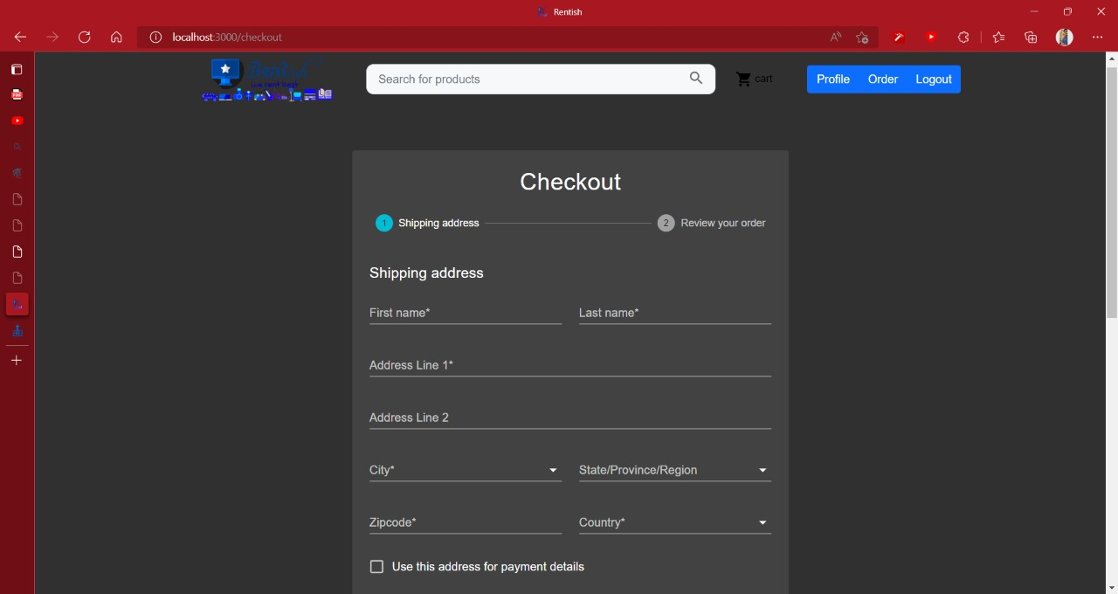

Fig : 7. 2 Checkout Address Form

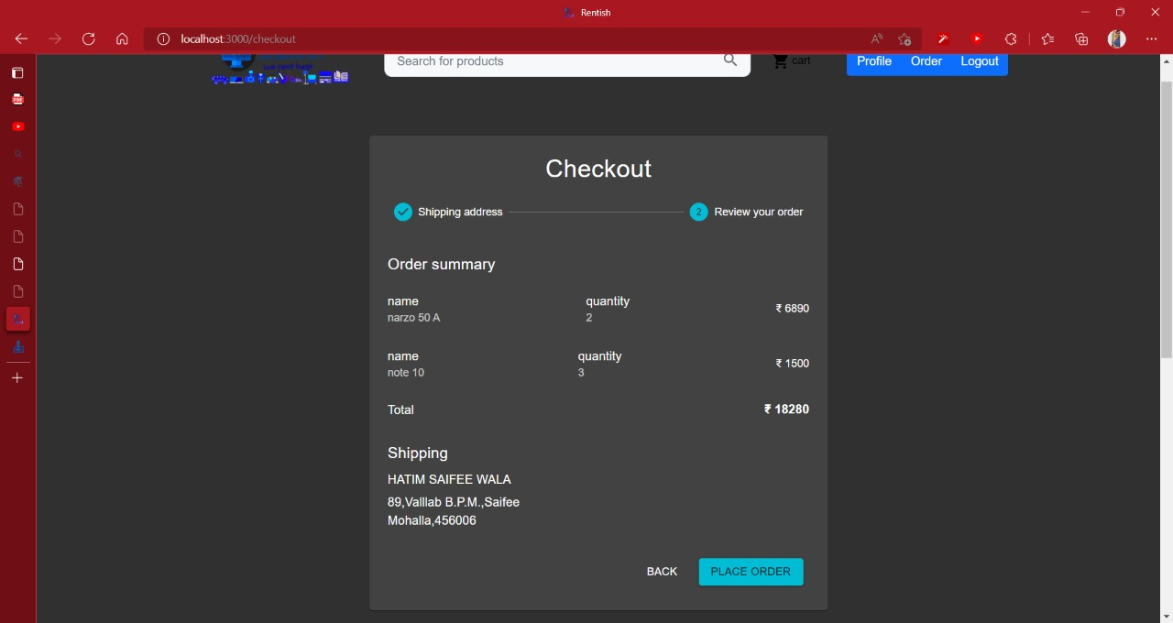

Fig : 7.3 Checkuot Order summary page

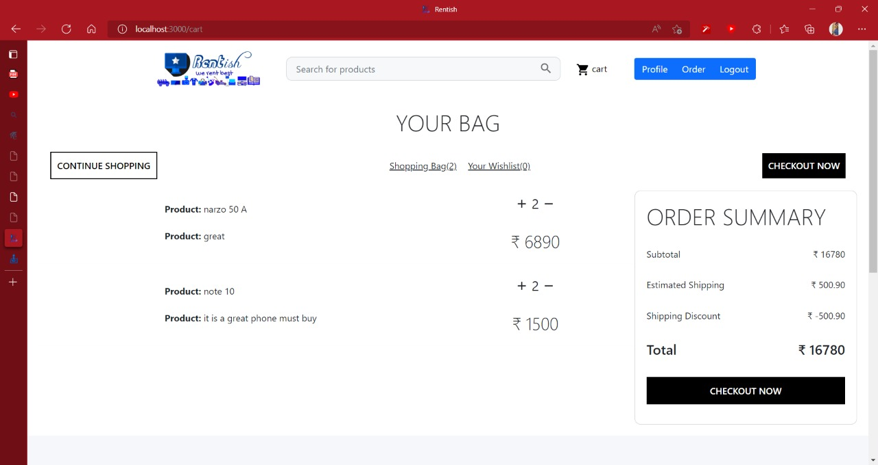

Fig : 7.4 Cart Page

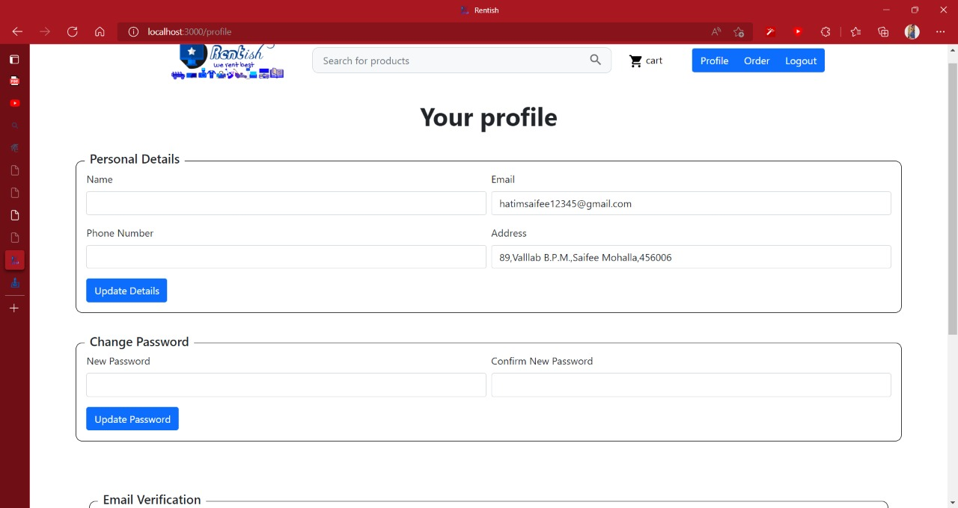

Fig : 7.5 Profile Page

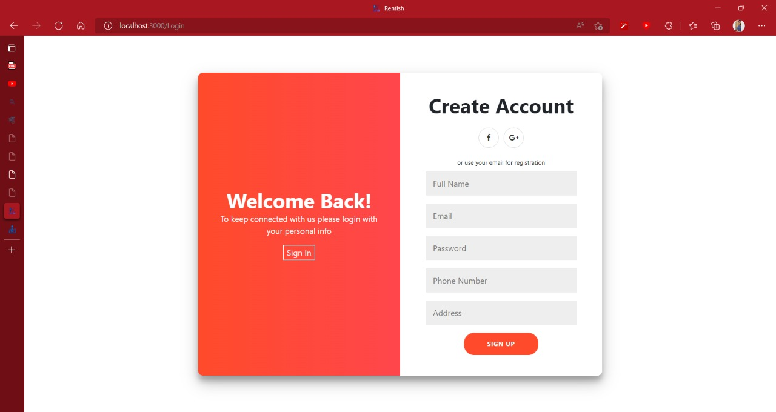

Fig : 7.6 Signup page

**References**

**Book:**

[1] Henry Chan (Author), Raymond Lee (Author), Tharam Dillon (Author) and Elizabeth Chang (Author). “E-Commerce: Fundamentals and Applications”.

**Research sites:**

[2] Kieraya Furnishing Solutions Pvt. Ltd. "https://www.furlenco.com".

[3] NoBroker.in “https://furniture.nobroker.in/”.

[4] RentMacha "https://www.rentmacha.com".

**Reference Youtube channel:**

[5] Lama Dev (Youtube) “React Node.js E-Commerce App Full Tutorial (REDUX - Stripe - JWT ) - MERN Stack Shopping App”.

[6] Thapa Technical (Youtube) “MERN Stack Tutorial 2021”.